Carrie Jeske 2018 Speaking Topics

Titles (detailed promo descriptions on pages below photos)
- Deal or Dud? Learn to Spot the Next Big Product Idea

- Inventing Techniques to Create Product Ideas for Walmart

- Prototypes & Demo Videos That Sell Ideas “As Seen On TV”

- Market Viability Testing & Licensing in “As Seen On TV” DRTV

- Licensing Agreement Fundamentals

- As Seen on TV Invention Licensing & Private Product Idea Reviews

- Co-Inventing Workshop

Marketing Photos

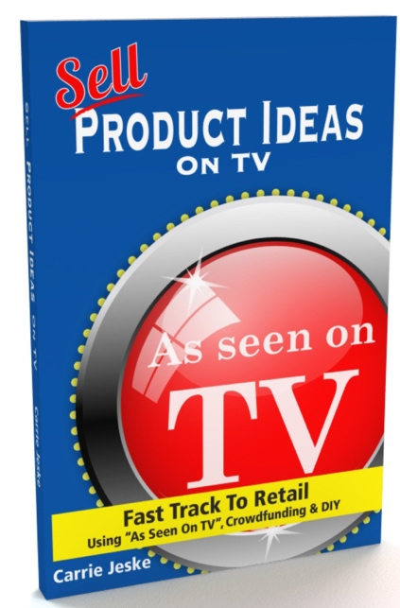

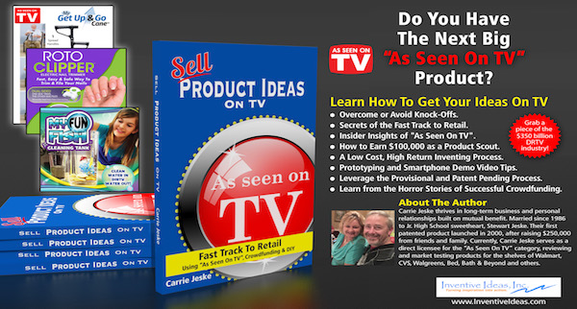
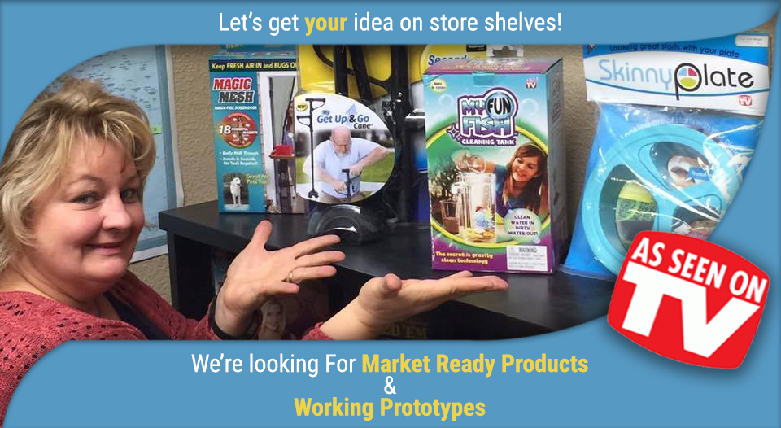

Deal or Dud? Learn to Spot the Next Big Product Idea by Carrie Jeske
AGENDA
- Understanding Distribution Channels for Consumer Products.
- As Seen on TV Industry Overview & Product Criteria
- Deal or Dud Product Reviews. Can you spot a dud?
- How to Submit Ideas & Product Scouting
- Pitch Your Own Product Idea.
  - (3-minute pitch with 3-minute review feedback. Bring a handmade prototype or market ready product. No patent required. NDA’s available.)

DATE / TIME:
LOCATION:
LOCAL HOST:
GET TICKETS:

NEED MORE INFO?

Carrie Jeske is a direct licensee looking for new concept and market ready products for the “As Seen On TV” industry. In this workshop, you’ll learn how to license your product, with or without a patent, using a well-made prototype and smart phone demo video.

Will It Launch pays full inventor royalties and finders fees.

Successful product rollouts on TV include: Magic Mesh, Windshield Wonder, RotoClipper, Easy View HD, My Fun Fish, Get Up And Go Cain, 60 Second Salad – which went viral.

Carrie Jeske Introduction Video
(Video Link) https://youtu.be/IIqtpQDF7Vk

Carrie Jeske Book on Amazon. Audio | Print | E-book

BUY NOW Button (Link)
https://www.amazon.com/Sell-Crowdfunding-Products-Kickstarter-Indiegogo/dp/1520786557

(Video Link)
https://youtu.be/HhDjiQ07Iks

To connect with Carrie Jeske contact:

Inventive Ideas, Inc. non-TV product ideas.
Will It Launch “As Seen On TV” and DRTV product ideas.

Inventing Techniques to Create Product Ideas for Walmart by Carrie Jeske
AGENDA
- As Seen on TV Shelf Space Overview & Product Criteria
- Inventing Techniques & Brainstorming Session
- How to Submit Ideas & Product Scouting
- Pitch Your Own Product Idea.
  - (3-minute pitch with 3-minute review feedback. Bring a handmade prototype or market ready product. No patent required. NDA’s available.)

DATE / TIME:
LOCATION:
LOCAL HOST:
GET TICKETS:

NEED MORE INFO?

Carrie Jeske is a direct licensee looking for new concept and market ready products for the “As Seen On TV” industry. In this workshop, you’ll learn how to license your product, with or without a patent, using a well-made prototype and smart phone demo video.

Will It Launch pays full inventor royalties and finders fees.

Successful product rollouts on TV include: Magic Mesh, Windshield Wonder, RotoClipper, Easy View HD, My Fun Fish, Get Up And Go Cain, 60 Second Salad – which went viral.

Carrie Jeske Introduction Video
(Video Link) https://youtu.be/IIqtpQDF7Vk

Carrie Jeske Book on Amazon. Audio | Print | E-book

BUY NOW Button (Link)
https://www.amazon.com/Sell-Crowdfunding-Products-Kickstarter-Indiegogo/dp/1520786557

(Video Link)
https://youtu.be/HhDjiQ07Iks

To connect with Carrie Jeske contact:

Inventive Ideas, Inc. non-TV product ideas.
Will It Launch “As Seen On TV” and DRTV product ideas.

Prototypes & Demo Videos That Sell Ideas “As Seen On TV” by Carrie Jeske

AGENDA
- As Seen on TV Shelf Space Overview & Product Criteria
- Types of Prototypes & When To Use Them
- How to Submit Ideas & Product Scouting
- Pitch Your Own Product Idea.
  - (3-minute pitch with 3-minute review feedback. Bring a handmade prototype or market ready product. No patent required. NDA’s available.)

DATE / TIME:
LOCATION:
LOCAL HOST:
GET TICKETS:

NEED MORE INFO?

Carrie Jeske is a direct licensee looking for new concept and market ready products for the “As Seen On TV” industry. In this workshop, you’ll learn how to license your product, with or without a patent, using a well-made prototype and smart phone demo video.

Will It Launch pays full inventor royalties and finders fees.

Successful product rollouts on TV include: Magic Mesh, Windshield Wonder, RotoClipper, Easy View HD, My Fun Fish, Get Up And Go Cain, 60 Second Salad – which went viral.

Carrie Jeske Introduction Video
(Video Link) https://youtu.be/IIqtpQDF7Vk

Carrie Jeske Book on Amazon. Audio | Print | E-book

BUY NOW Button (Link)
https://www.amazon.com/Sell-Crowdfunding-Products-Kickstarter-Indiegogo/dp/1520786557

(Video Link)
https://youtu.be/HhDjiQ07Iks

To connect with Carrie Jeske contact:

Inventive Ideas, Inc. non-TV product ideas.
Will It Launch “As Seen On TV” and DRTV product ideas.

Market Viability Testing & Licensing in “As Seen On TV” DRTV by Carrie Jeske
AGENDA
- Save Thousands of Dollars and Years of Time with Market Viability Testing
- Using Low Cost Prototypes To Test Consumer Responsiveness
- How to Submit Ideas & Product Scouting
- As Seen on TV Licensing Secrets
- Pitch Your Own Product Idea.
  - (3-minute pitch with 3-minute review feedback. Bring a handmade prototype or market ready product. No patent required. NDA’s available.)

DATE / TIME:
LOCATION:
LOCAL HOST:
GET TICKETS:

NEED MORE INFO?

Carrie Jeske is a direct licensee looking for new concept and market ready products for the “As Seen On TV” industry. In this workshop, you’ll learn how to license your product, with or without a patent, using a well-made prototype and smart phone demo video.

Will It Launch pays full inventor royalties and finders fees.

Successful product rollouts on TV include: Magic Mesh, Windshield Wonder, RotoClipper, Easy View HD, My Fun Fish, Get Up And Go Cain, 60 Second Salad – which went viral.

Carrie Jeske Introduction Video
(Video Link) https://youtu.be/IIqtpQDF7Vk

Carrie Jeske Book on Amazon. Audio | Print | E-book

BUY NOW Button (Link)
https://www.amazon.com/Sell-Crowdfunding-Products-Kickstarter-Indiegogo/dp/1520786557

(Video Link)
https://youtu.be/HhDjiQ07Iks

To connect with Carrie Jeske contact:

Inventive Ideas, Inc. non-TV product ideas.
Will It Launch “As Seen On TV” and DRTV product ideas.

Licensing Agreement Fundamentals
AGENDA
- Where to Look & How to Request a Licensing Agreement
- Getting to the Right Contact & What to Say
- Licensing Terms That Make Money
- As Seen on TV Licensing Process & Secrets
- How to Submit Ideas & Product Scouting
- Pitch Your Own Product Idea.
  - (3-minute pitch with 3-minute review feedback. Bring a handmade prototype or market ready product. No patent required. NDA’s available.)

DATE / TIME:
LOCATION:
LOCAL HOST:
GET TICKETS:

NEED MORE INFO?

Carrie Jeske is a direct licensee looking for new concept and market ready products for the “As Seen On TV” industry. In this workshop, you’ll learn how to license your product, with or without a patent, using a well-made prototype and smart phone demo video.

Will It Launch pays full inventor royalties and finders fees.

Successful product rollouts on TV include: Magic Mesh, Windshield Wonder, RotoClipper, Easy View HD, My Fun Fish, Get Up And Go Cain, 60 Second Salad – which went viral.

Carrie Jeske Introduction Video
(Video Link) https://youtu.be/IIqtpQDF7Vk

Carrie Jeske Book on Amazon. Audio | Print | E-book

BUY NOW Button (Link)
https://www.amazon.com/Sell-Crowdfunding-Products-Kickstarter-Indiegogo/dp/1520786557

(Video Link)
https://youtu.be/HhDjiQ07Iks

To connect with Carrie Jeske contact:

Inventive Ideas, Inc. non-TV product ideas.
Will It Launch “As Seen On TV” and DRTV product ideas.

As Seen on TV Invention Licensing & Private Product Idea Reviews with Carrie Jeske
AGENDA
- Where to Look & How to Request a Licensing Agreement
- Getting to the Right Contact & What to Say
- Licensing Terms That Make Money
- As Seen on TV Licensing Process & Secrets
- How to Submit Ideas & Product Scouting
- Pitch Your Own Product Idea.
  - (3-minute pitch with 3-minute review feedback. Bring a handmade prototype or market ready product. No patent required. NDA’s available.)

DATE / TIME:
LOCATION:
LOCAL HOST:
GET TICKETS:

NEED MORE INFO?

Carrie Jeske is a direct licensee looking for new concept and market ready products for the “As Seen On TV” industry. In this workshop, you’ll learn how to license your product, with or without a patent, using a well-made prototype and smart phone demo video.

Will It Launch pays full inventor royalties and finders fees.

Successful product rollouts on TV include: Magic Mesh, Windshield Wonder, RotoClipper, Easy View HD, My Fun Fish, Get Up And Go Cain, 60 Second Salad – which went viral.

Carrie Jeske Introduction Video
(Video Link) https://youtu.be/IIqtpQDF7Vk

Carrie Jeske Book on Amazon. Audio | Print | E-book

BUY NOW Button (Link)
https://www.amazon.com/Sell-Crowdfunding-Products-Kickstarter-Indiegogo/dp/1520786557

(Video Link)
https://youtu.be/HhDjiQ07Iks

To connect with Carrie Jeske contact:

Inventive Ideas, Inc. non-TV product ideas.
Will It Launch “As Seen On TV” and DRTV product ideas.

Co-Inventing Workshop with Carrie Jeske
  - Collaborate & Brainstorm Money-Making Product Inventions. NDA’s Signed.

AGENDA
- Review Licensing Strategy, Royalty Split Options & Confidentiality
- Explaining Inventing Techniques For Simple Products
- Brainstorming PROBLEMS & TRENDS
- Collaborate on Product Design and Unique Features/Benefits.
- Discuss Prototype and Demo Video
- Agree & Confirm Next Steps

DATE / TIME:
LOCATION:
LOCAL HOST:
GET TICKETS:

NEED MORE INFO?

Carrie Jeske is a direct licensee looking for new concept and market ready products for the “As Seen On TV” industry. In this workshop, you’ll learn how to license your product, with or without a patent, using a well-made prototype and smart phone demo video.

Will It Launch pays full inventor royalties and finders fees.

Successful product rollouts on TV include: Magic Mesh, Windshield Wonder, RotoClipper, Easy View HD, My Fun Fish, Get Up And Go Cain, 60 Second Salad – which went viral.

Carrie Jeske Introduction Video
(Video Link) https://youtu.be/IIqtpQDF7Vk

Carrie Jeske Book on Amazon. Audio | Print | E-book

BUY NOW Button (Link)
https://www.amazon.com/Sell-Crowdfunding-Products-Kickstarter-Indiegogo/dp/1520786557

(Video Link)
https://youtu.be/HhDjiQ07Iks

To connect with Carrie Jeske contact:

Inventive Ideas, Inc. non-TV product ideas.
Will It Launch “As Seen On TV” and DRTV product ideas.

Popular past topics include:
- How To Learn Low Cost, High Reward Inventing Strategies
- How To Earn $330,000 Inventing Products For TV
- How To Earn $27,500 in Finder’s Fee’s… While Shopping!
- Co-Inventing Workshop – 2-hour session to full day.
- Witty Inventions Workshop - 2 hour session to full day.
- Understanding Market Viability Testing Before Patent or Manufacturing.
- Manufacturing Gotcha’s. What to watch for when hiring overseas.

